Set up and install

* Node 10.0.0 (use npm n for different versions)
* Angular 6.0.0 (Install Angular in the project directory)
* Docker desktop
* mongoDB locally

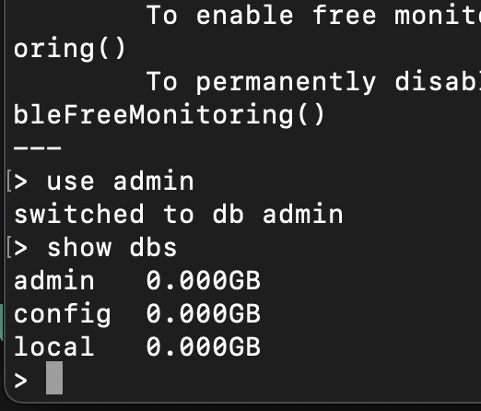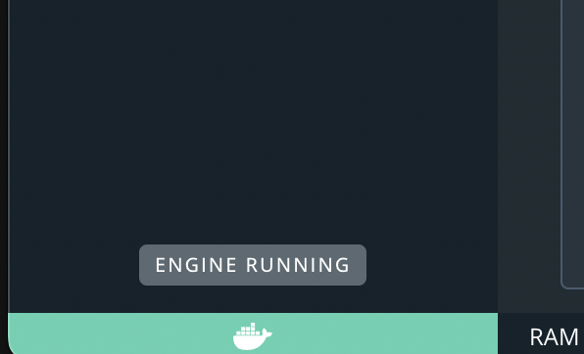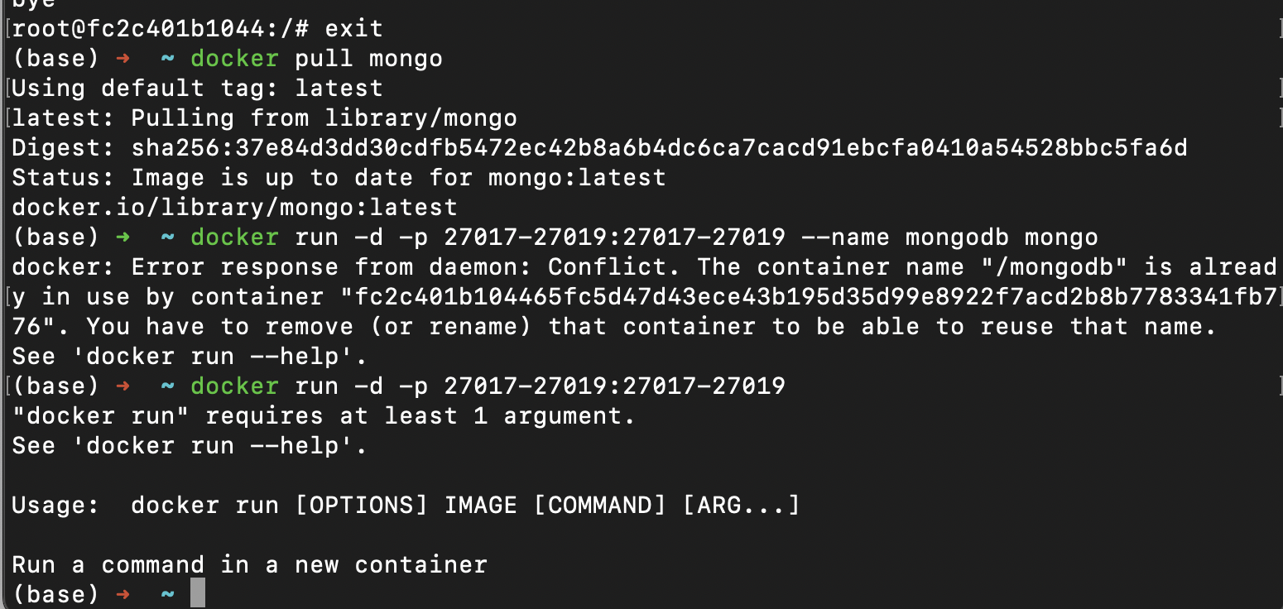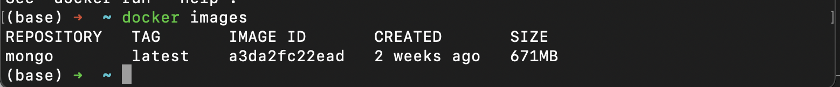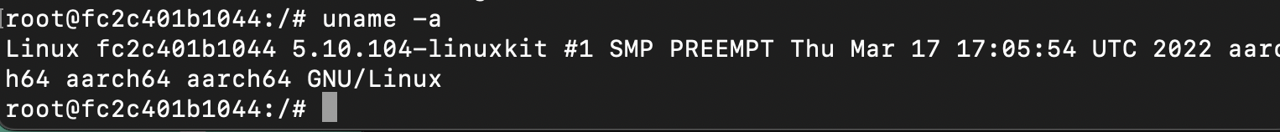

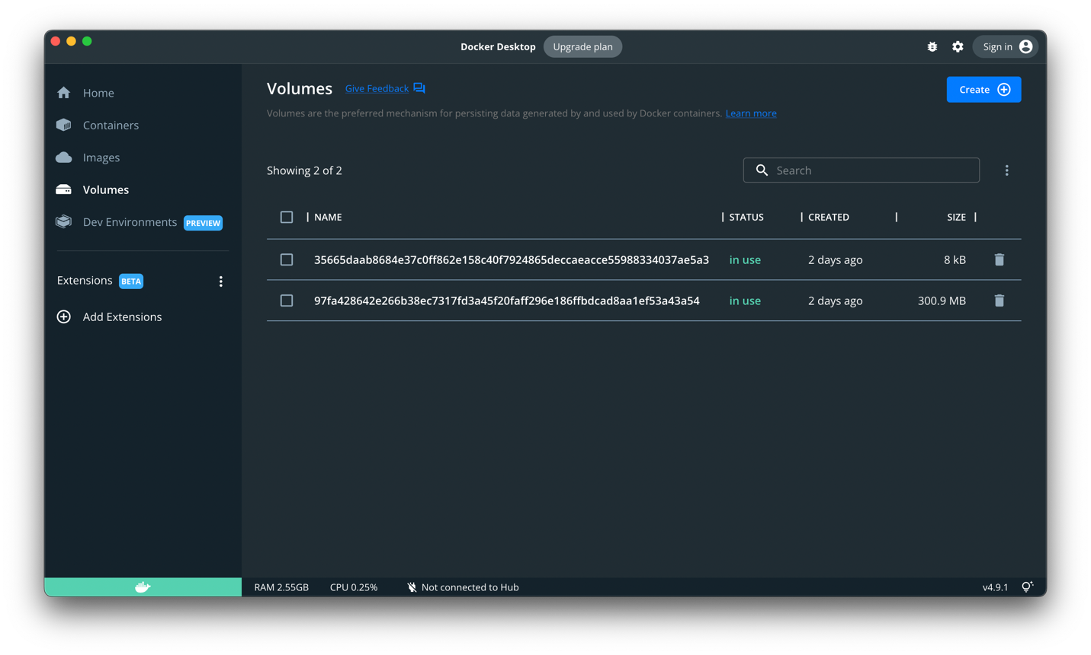

```console

node --version

node --version

v18.4.0

brew install n

sudo n 10.0.0

n ls

node/10.0.0

node/12.16.3

npm install @angular/cli@6.0.0

ng --version

docker pull mongo

docker run -d -p 27017-27019:27017-27019 --name mongodb mongo

docker exec -it mongodb bash

docker pull mongo

docker images

```

# Running Docker

To Reopen the Linux terminal in the docker image

```console

docker exec -it mongodb bash

mongo

use admin

show dbs

uname -a

Ctrl+D (exit Docker remote bash shell)

```

Resources

DOCKER

Dockerfile reference

<https://docs.docker.com/engine/reference/builder/>

Best practices for writing Dockerfiles

<https://docs.docker.com/develop/develop-images/dockerfile_best-practices/>

Sample application

<https://docs.docker.com/get-started/02_our_app/>

Cheatsheet of commands for **Dockerfile**

[**https://kapeli.com/cheat_sheets/Dockerfile.docset/Contents/Resources/Documents/index**](https://kapeli.com/cheat_sheets/Dockerfile.docset/Contents/Resources/Documents/index)

Learn to build and deploy your distributed applications easily to the cloud with Docker

Written by [Prakhar Srivastav](https://prakhar.me/)

[**https://docker-curriculum.com/#getting-started**](https://docker-curriculum.com/#getting-started)

Introduction To Docker and Docker Containers

[Docker Client, Images and Containers](https://www.youtube.com/watch?v=CcxbHkqzJuI)

[14:21](https://www.youtube.com/watch?v=CcxbHkqzJuI)

What are application containers and what problems do they solve?

<https://nodramadevops.com/2019/06/what-are-application-containers-and-what-problems-do-they-solve/>

**What are containers and why do you need them?**

<https://www.cio.com/article/247005/what-are-containers-and-why-do-you-need-them.html>

Docker container library

<https://hub.docker.com>

docker pull

<https://docs.docker.com/engine/reference/commandline/pull/>

docker stop

<https://docs.docker.com/engine/reference/commandline/stop/>

Docker sign-up

<https://hub.docker.com/signup>

AWS

<https://sway.office.com/UPuRI3xSglnu7VW2?ref=Link&loc=play>

AWS In 10 Minutes | AWS Tutorial For Beginners | AWS Training Video | AWS Tutorial | Simplilear

<https://www.youtube.com/watch?v=r4YIdn2eTm4>